(s) Nikodem Drabik

   McDermott

Contents

Project Requirements. 3

Basic Requirements: 3

Our Understanding: 3

Mission Statement 4

Value We provide 4

Application Purpose POV 4

Additional Features that would benefit the client: 4

User Analysis/ Possible Users: 4

Contractor/Device Installer: 4

Supervisor / IT administrator 5

Hobbyist 5

Project Roles 7

Project TimeLine 8

Front End Design 10

Iteration One: 10

Iteration Two: 13

LoRaWAN and LoRA RF 15

Technical Analysis 16

Initial Security analysis of applications and threats: 16

Important Laws: 17

How it applies: 17

Quality Assurance 18

What is it? 18

Why it’s needed? 18

How will it be achieved? 18

KPI’s 19

What is it? 19

Our KPI’s 19

Approval Process 20

Firebase: 20

Database Explained: 20

Database Low Fidelity Plan. 20

Features to be used: 20

To look out for: 21

Proof of Concept 21

Firebase Concept/Testing 21

Rules for test database used of Testing 21

Table Designs: 22

Database CRUD: 23

Flutter Concept/Testing 24

Project 2003 GitHub Repository 26

Additional Resources 26

Additional Research 26

Topic - AI (Late Stage idea) 26

Follow Structure this: 26

# Project Requirements.

## Basic Requirements:

A database app to manage the lifecycle of connected IoT assets from cradle to grave. As a device moves from manufacture into installation, operation, and eventual removal and recycle there is a need to record information about the device, e.g. serial number, owner, location, installation, connection, maintenance etc. The project objective is an app that records device associated information into a database to record its life history as a 'source of truth' for use by device manufacturers and business users. Emphasis on this project would be a UI experience that is more oriented towards the workflow of the lifecycle.

1)      Use of Firebase to manage data.

2)      API calls preferred to abstract out services so recommended to use microservice architecture.

3)      The project should be extendable to multiple clients running off the same database.

4)      There should be option for data to be stored on client side or client-side API keys, but functionality on cloud.

5)      Stretch goals - think scalability from 5 devices to 1000 or more.

## Our Understanding:

A structured way to keep track of devices in an IoT-based application allows for the user to monitor known statistics and update data for each device in whatever format they like. It should be flexible by allowing dynamic grouping and user-saved documents and files while also being structured enough to serve a large customer base.  – **technical aspect of Database**

A mobile interface that allows businesses and contractors to monitor and maintain their IOT devices in the field and update each device in real time. Each device should have a GPS coordinate, last serviced, and notes about the device and how it should be maintained in the future. - **implement a Real time Database**

The User Interface should be easy to understand for users of different tech literacy levels as this could be used by a manner of people tracking servers to cow trackers. **- the application of User Interface**

## Mission Statement

To provide a software solution to manage and track the Life Cycle a wide range of IoT devices in one simple application.

## Value We provide

With the shutdown of the Amazons IOT solution we come to fill in the market gap to provide a solution for the specific use case scenarios that our possible clients. We provide a simple solution to tackle the issue of not being able to track IoT devices while they are deployed in the field and the remain aspects of its Life Cycle.

## Application Purpose POV

Create software that allows a business, and individuals track their IOT devices lifecycle from manufacture to installation, operation, maintenance, and eventually, recycling if possible.

Whether managing a handful of devices to scaling to thousands, our solution should be able to adapt to meet the diverse needs of clients, offering flexibility in our client-side integration as well as on our database.

### Additional Features that would benefit the client:

Maintenance scheduling

QR code scanning/reading to easily access device information.

LoRaWAN and LoRA RF communication with devices *more information found under LoRaWAN and LoRA RF

## User Analysis/ Possible Users:

### Contractor/Device Installer:

#### Who are they

This person would be working for the company who owns the device.

The main uses of the app for this user would be:  
 Modify Maintenance Logs

Adding Devices to company database.

Removing Devices from database

#### Technical Ability

The user may not be the most technically inclined to navigate a complicated app. They can range for 18 years olds up to 65 years as it’s likely to be a manual labour position. The app must be easily teachable to all user.

### Supervisor / IT administrator

#### Who are they

This person would be managing all the devices from a centralised location like and office.

They will be in charge of ensuring all devices are up to date and if not ensure a contractor is sent to fix the issue at hand. They must have access to all devices that are in their network and no other network.

#### The main use of the app for this user?

This user will mostly be using the manage device section of the app as they are not likely to be creating new user in the device. They may be centralised in one location or be moving from one location to another so they must have remote access like a contractor to their service.

They may need to create updated or delete devices in case of issues in the real world and possible remoteness of the devices not allowing for real time updates to the database or fix human errors created by others.

#### Technical Ability

This user can be a wide range of of age however often are older due to the seniority of the position meaning that the app mist be tailored to them and their specific uses.

#### Problems this app may solve for them

An active view of most of there deployed devices. It will allow them to manage them better and be aware of their status at moment’s notice. It should fix issues of large amount of paper-based documentation that need to be looked through to find the status of a device.

#### Important features they would benefit from?

Notifications – these would provide reminders for maintenance schedules.

View of all current devices and their current stages in their lifecycle and last maintenance date.

### Hobbyist

#### Who are they

This person enjoys experimenting and utilising and messing with many electronic devices and have many devices that they need to maintain in their home for example routers, servers, NAS devices.

#### The main user of the software

They would like to keep record of all their devices they have deployed. The reason for this may be that they want to keep everything up to date with the lates driver and software updates. For this they may benefit for man app that they input data and informs them every 6 months to update their systems software.

#### Technical Ability

This type of user will be very skilled in this area as this is their passion they are likely to be much more technically inclined than the average person with tech and likely want to modify the app to be more applicable to their specific user case scenario.

#### The main issue this software would solve for them.

This software would solve the issue of maintenance scheduling of devices and life cycle of devices as all devices have a expected life cycle. This would help this users be on top of their device servicing like a MOT reminder for road users. It will help them ensure all devices are in their best shape.

# Project Roles

Tom-

**Front end/ UI/Flutter**

Task: To design and manufacture a UI for the client

Niko-

**Project Oversight, Front-end/Back-end assistance**

Task: To work with all team members to help with the deliverables. Assist in the deployment of UI and its communication with Firebase API

Joe-

**Firebase/Backend, Security of Project**

Task: To design and manufacture Firebase infostructure. Ensure that it is secure to be used by the clients.

# Stakeholders

## Client

In this project Farfields represented by John McDermott is our client that is going to be with us thought the year helping to be the main stakeholder providing critical feedback and guidance during the development. He will ensure that what the outcome is aligns with the key deliverables he expected

## Users

These are the people that we are creating the application for. They are the people who are likely going to be using this software. Understanding this Stakeholders needs and wants in critical for the projects success; due to the fact they are the centrepiece for this project.

## Team

Finaly the development team that Compromises of Niko, Tom ,Joseph who are developing this software. The team works closely with the client to ensure that the project aligns with the outlined objectives and expectations.

Each team member brings valuable qualities in the help of developing a high quality product.

# Project TimeLine

Project Start- October 25:

|  |  |  |  |  |  |  |  |  |  |  |  |  |
| --- | --- | --- | --- | --- | --- | --- | --- | --- | --- | --- | --- | --- |
|  | **At Risk?** | **TASK NAME** | **FEATURE TYPE** | **RESPONSIBLE** | **STORY POINTS** | **START DATE** | **END  DATE** | **DURATION  in days** | **STATUS** | **PRIORITY** | **COMMENTS** |  |
|  |  | Sprint Week 1 |  |  |  | 11/08 | 11/29 | 28 |  |  |  |  |
|  |  | Planning application |  | Team |  |  |  |  | Complete | High | To plan what type of software we will implement |  |
|  |  | User Analysis |  | Team |  |  |  |  | Complete | High | Analys the users of the app |  |
|  |  | Sprint Planning |  | Team |  |  |  |  | Complete | High | Plan future sprints |  |
|  |  | Sprint Week 2 |  |  |  |  |  |  |  |  |  |  |
|  |  | Plan Database | Main Database | Joeseph - Niko |  | 9/12/2024 | 16/12/2024 |  | Needs Review | Medium | Create database |  |
|  |  | Plan UI | Main UI | Tom - Niko |  | 09/12 | 16/12/2024 |  | Complete | Medium |  |  |
|  |  | Create Write Up |  | Niko - Team |  | 09/12 | 16/12/2024 |  | Overdue | Medium |  |  |
|  |  | Begin Presentation |  | Niko - Team |  | 09/12 | 16/12/2024 |  | Overdue | Medium |  |  |
|  |  | Sprint Week 3 |  |  |  |  |  |  |  |  |  |  |
|  |  | Implement Firebase create C++/C CRUD command files | Main Database | Team |  | 08/01 | 28/01/25 |  | Not Started | High |  |  |
|  |  | Implement Basic UI in flutter | Main UI | Team |  | 08/01 | 28/01/25 |  | Not Started | High |  |  |
|  |  |  |  |  |  | 08/01 | 28/01/25 |  |  |  |  |  |
|  |  | Sprint Week 4 |  |  |  |  |  |  |  |  |  |  |
|  |  | Create API for firebase and flutter connection | Main Database | Niko - Joseph |  | 29/01 | 16/02 |  | Not Started | High |  |  |
|  |  | Create Tracker Page to see items in detail | Main UI | Tom - Niko |  | 29/01 | 16/02 |  | Not Started | High |  |  |
|  |  |  |  |  |  |  |  |  |  |  |  |  |
|  |  | Sprint Week 5 |  |  |  |  |  |  |  |  |  |  |
|  |  |  |  |  |  |  |  |  |  |  |  |  |
|  |  |  |  |  |  |  |  |  |  |  |  |  |
|  |  |  |  |  |  |  |  |  |  |  |  |  |

Project End- May 6:

# Research

## Statement

The project aims to develop a database application to manage the lifecycle of IoT devices.

**As stated, it requires:** Lifecycle Tracking

User oriented UI

Firebase Database

Firebase API based microservice architecture.

## Existing Solutions

### AWS IoT

Amazon states “the only cloud vendor that combines data management and rich analytics to create easy-to-use services designed for high-volume IoT data”

AWS IoT Is the largest cloud vendor for data management and analytics that provides real time analytics of the connected devices.

They state that is built upon a secure and proven cloud infrastructure and IoT network that scales to billions of devices

#### Pros

Scalability

Integrated with AWS services

Strong Security practices

#### Cons

Expensive for small-scale users with budget constraints

Complex to maximise to its full potential

Very reliant on the AWS ecosystem

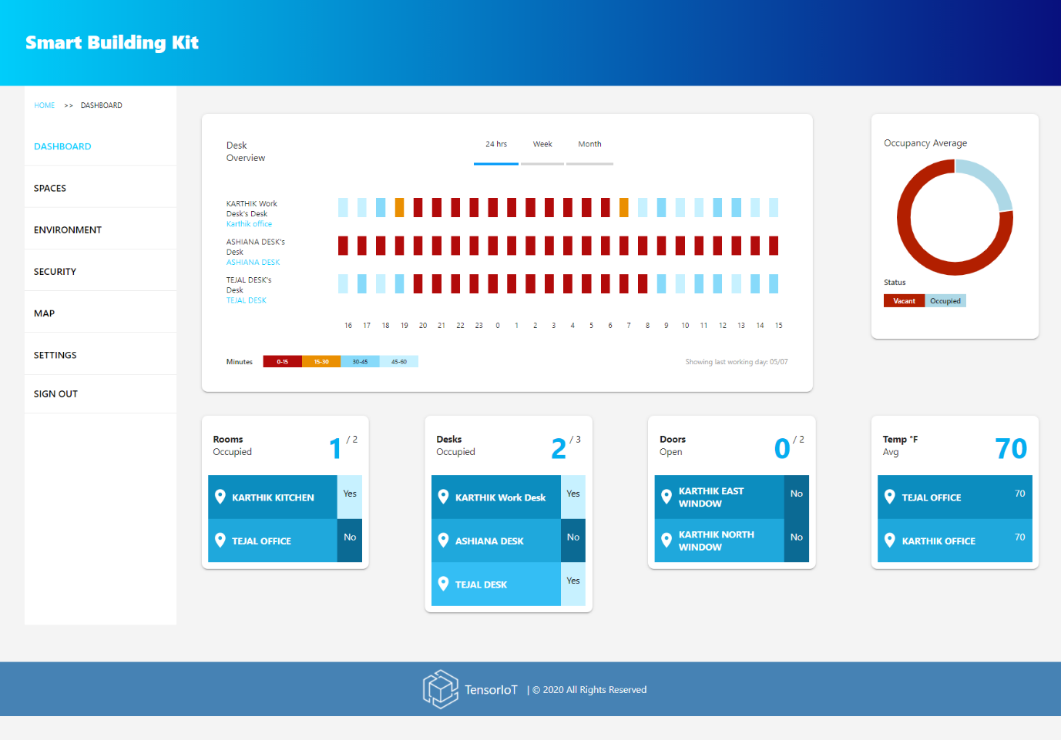

[image by Amazon]

In the image above it shows the dashboard for the LoRaWAN system to what seems to be a small office space indicating occupied desks and rooms, open doors and two thermometer readings.

### Microsoft Azure IoT

A collection of Microsoft managed cloud services that allows the user to monitor and control their IoT devices at a scale. It specializes in providing comprehensive tools for device analytics. It is meant to seamlessly integrate with Microsoft tools included Power BI and Dynamics 365 which are two analytics tools that help visualize data for users and customers.

#### Pros

Scalable

Integrated with Azure AI services

Built in IoT Security features

#### Cons

Locked into Microsoft Eco-system

Price prohibits small scale or experimental projects

### Our Difference

Our proposed solution offers several unique advantages that set it apart from the existing solutions, such as AWS IoT and Microsoft Azure IoT. These differences are aimed at making our application more accessible, flexible, and user-centric:

1. Unlike AWS IoT and Azure IoT, which are deeply tied to their respective ecosystem at the roots, our solution is platform-agnostic. This ensures that businesses and individuals can integrate our software into their workflows without the need of being locked into a specific platform. This provides greater flexibility and cost effective alternatives to software solutions.
2. Our application prioritizes a user-oriented interface that caters to varying levels of technical expertise. By focusing on intuitive design and streamlined workflows, we ensure that all stakeholders can use the app with minimal training. This emphasis on usability makes our solution stand out compared to the more complex dashboards offered by competitors.
3. While AWS and Azure focus heavily on analytics and scalability, our solution emphasizes lifecycle tracking. From manufacture to maintenance and eventual recycling, our app provides tools specifically designed to support every stage of an IoT device's life. Maintenance scheduling, QR code integration, and real-time device status updates are just some of the features tailored to the operational needs of end users.

# LoRaWAN and LoRA RF

LoRaWAN

This consists of many end devices connected to gateways that receive messages using ALOHA-based protocols so that end devices do not need to be pared to specific gateways yet be within a gateway's range to send signals. These messages are then received by the network server; if it receives multiple copies of the same message, it only keeps one.

End devices can be a sensor, an authenticator, or even both. They are likely to be battery operated and connect via LoRa radio frequency modulation.

Gateways can be categorised into indoor (picocell) and outdoor (mactocell) gateways.

Indoor gateways are cost-effective and best for a location with many obstructions to the wireless signals. They have internal antennas or external pigtail antennas. Depending on the building, its possible for them to receive signals from over several kilometres away.

Outdoor gateways provide larger coverage in both urban and rural areas. Usually attached to cell towers or tall buildings.

Lastly, you need 3 servers: a network server, an application server, and a join server.

Pros -

Low power: battery-powered

Long range: in In Kilometres

Cost-effective: uses unlicensed radio frequency and low set-up cost

Scalable—can support thousands of devices on 1 gateway.

Secure *

Cons-

Difficult to maintain custom protocols

LoRa RF is not designed for scalability

*\*Security*

LoRaWAN security

Built-in security mechanisms to protect data confidentiality, integrity, and authenticity.

Uses the AES-128 encryption for end-to-end as well as 2-layer encryption using network layer encryption and application layer encryption.

This is because its less complex, more efficient, and more cost-effective to run, which is a large point for most implementations. Yet 128 is still secure enough for current standards.

# Front End Design

## Iteration One:

The design needs to be modular and simple. The application should be easy to use for a wide range of people who are technical. The app is going to feature 5 distinct colours for a theme.

The app's main background will be #EDF6F9 with the font colour being #303633.

For our frontend design we will be using Flutter allowing us to port to many types of devices including phone, desktop and web giving clients many ways to access the software our primary focus will be mobile support allowing contractors and admins to add new devices on site and in real time.

Iteration two features only three colours: white, royal blue and charcoal black. I Chose royal blue as many people associate blue with technology and with the app being a tech tracker I thought it was a perfect choice of colour. The charcoal black is a less harsh black and clashes less with the colour theme.

## Iteration Two:

After meeting with our client, we concluded for what the UI colour scheme should be. The client has a startup company “resegva” that he has designed the website for and follows the following colour scheme convention.

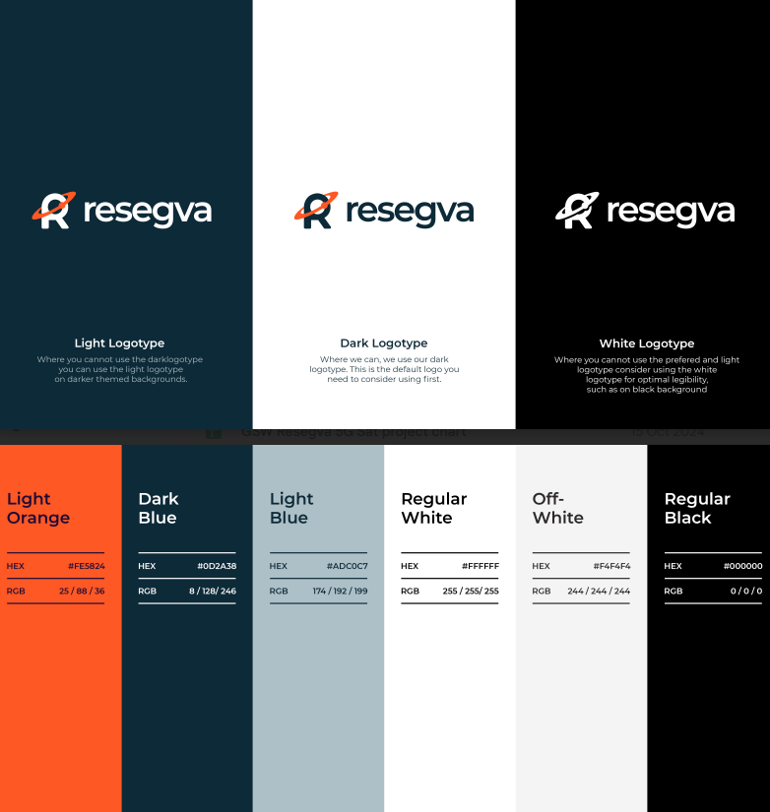

Using the colour scheme the client provided I was able to amend my initial prototype. Below is the new and improved version of the UI.

# Technical Analysis

## Initial Security analysis of applications and threats:

|  |  |  |
| --- | --- | --- |
| Risk | Affect | Countermeasure |
| User spoofing | Gain unauthorised access | 2Fa/MFA when logging in |
| Poor data base encryption | Malicious access to large quantity of data from clients stored in the database | Encrypt all data in the database to minimise the possibility |
| API attacks | Possible to infiltrate the database using illegitimate requests using the API | Ensure all requests are authorised and possibly create a rate limit on request to reduce DOS attacks on the DB |
| Malware/Ransomware | data base is taken from our control. | Frequent backups to a secondary database to minimise the threats |
| Man in the middle attack | The attacker intercepts a valid communication path between user and software and can gain access to sensitive information or inject malicious software or code into the database to gain access | Create a secure path using a multiteam of validation certificates such as TLS and SSL |
| Firebase formatting | May lead to unauthorised CRUD functionalities being performed | Format for minimum access to database. |
| File Uploads | Infected files being uploaded to the system | Ensure only authorised formats like JPG, PNG or dxcs are used and not.exe or.py to minimise the possibility of a threat |
| API key expose | Can lead to unauthorised request being sent to the firebase | Use a system that only lets authorised usage of the API port by authorised individuals. |
| Data base breaches | Data base breached by a method mentioned | To increase security, encrypt and hash all data that seems sensitive. |

### Important Laws:

There are many laws that we need to follow to ensure the project abides by the UK and EU laws, as this is where its likely to be dispatched too.

GDPA 2018 (UK specific)

GDPR (EU wide)

Computer misuse act—to be followed by all when interacting with the software

Freedom of Information act: allows user to be aware of what data is stored on our servers about them

#### Research:

Digital economy act 2019

Network and Infrastructure Security ACT 2018

Cyber Security ACT 2019

Network and Infrastructure Security Act 2018:

Perform regular risk assessments of the application to ensure that valid measures are taking place to minimise the security risk to the network.

The ACT requires us as a company to report any cyber security breaches that may affect our systems, such as cyber-attacks, breaches into our databases or networks, any ransomware or DDOS/DOS attacks, and compromise of critical infrastructure, insider attacks, or data leaks.

A couple of possible threats will likely be around our DB usage and API ports.

### How it applies:

Overall, as a team, we will need to apply and follow all rules and regulations that apply to our database, ensuring we store data securely, perform secure connections to the database, and limit access to the lowest possible viable level as to minimise possible security vulnerabilities. A large part of the security of our infrastructure is how it will be accessed. Depending, we will need to perform some user questioning to see the ways it will be accessing the network and be able to optimise the connectivity as stated before to minimise the possibility of attacks.

# Budget Analysis

For this project the budget need should be very small before deployment to the large scalability.

# Risk Management

Risk management is a critical component to ensure that the risk is identified analysed and mitigated proactively to ensure minimum damage occurs. This section potential risks their likely hood of happening mitigation strategies and contingency plan if it happens.

|  |  |  |  |  |
| --- | --- | --- | --- | --- |
| Risk | Likely hood (out of 10) | Impact | Mitigation strategies | Contingency plan |
| Software bugs | 8 | Low | Test code during production | Identify bugs and handle them |
| API Failure | 2 | High | Monitor API’s behaviour |  |
| Data Breach | 2 | High | Secure all code and all sensitive information with robust encryption | Notify affected users patch vulnerability and create a Incident Report |
| System Downtime - Maintenance | 5 | Medium | Inform users of the issue ahead of time |  |
| System Down | 3 | High |  |  |
| Unauthorized access | 4 | High | Implemented a RBAC model | Block suspected unauthorised accounts, investigate breach strengthen access policies notify users if affected |
| Performance Issues | 7 | Medium | Continuously monitor and test the software to address bottlenecks | Roll back of recent changes and implement hotfixes to ensure software operates as expected. |
| Unauthorized API calls | 2 | High | Restricted API calls to authorised accounts | Block unauthorized calls, notify all affected parties and update security. |
| Team Member Loss | 1 | High | Ensure all members are always aware of all current projects taking place and able to take over at any moment. | Delegate the team members workload among the remaining team members extend all deadlines re-do project requirements.  Inform all stakeholders. |

# Quality Assurance

## What is it?

Quality Assurance (QA) refers to the steps and measures taken to ensure that the final product meets high standards and aligns with the project requirements outlined in the brief. It is a process aimed at identifying and addressing potential issues during development, ensuring client satisfaction and project success.

## Why it’s needed?

It is an essential process to ensure that the final product meets the clients, industry standards and out expectations of what was expected to be the outcome.

The lack of QA can lead to the derailment of the project and the outcome not being what was expected. QA benefits In the continuous improvement of the project and a high-quality outcome.

## How will it be achieved?

This will be achieved through the following:

Communication with the client of the project in this case John McDermott from Fairfield’s

Team meeting ensuring that what everyone is doing aligns with the project plans and the main idea for the project outlined in the Project Requirements.

Have a plan signed off before implementation fully starts on the project on 7th of January. This will assist in ensuring that everyone has the same plan.

If issues arise during the project Process the following issues will be done:

**Step 1** Team meeting with Nikodem Tom Joseph. Discuss and locate the root problem and try to neutralize it.

**Step 2** If the issue persists allocate more resources to that area of the project

**Step 3** If the issue is larger and requires input from client, contact client and schedule a meeting. Otherwise skip this part.

**Step 4** Document the issue’s and what we learned from it

**Step 5** If the issue was taken longer than expected amend the sprint timeline

Lastly have continuous review of the QA plan at each step to ensure that its relevant to that section.

# KPI’s / Testing

## What is it?

Key Performance Indicators designed to analyse if the product performs as it was expected by the client.

For most KPI’s Sections we will perform test to ensure that they are within target.

## Our KPI’s

|  |  |  |
| --- | --- | --- |
| KPI | Description | Target |
| API response time | The API should have an average response around | <300ms |
| Data Completion | The number of devices in the database with all of the required data entered to ensure accurate tracking | >=95% - human error |
| Data Accuracy | The % of accurate data in the database against real information. Highly dependable on upkeep. | 95% - human error |
| Unauthorized logins blocked | Success rate of stopped access to the system with unauthorised credentials | 100% |
| Encrypted data | Data that is required to be encrypted is encrypted | 100% |
| RBAC( Role-Based access control) Accuracy | Percentage of access correctly granted/ denied based on their role | 100% |
| Unauthorized API calls detected | The % of unauthorised API calls caught and blocked | 100% |
| Data Breaches | Amount of data breaches in a tax year | 0 breaches |
| Data privacy compliance | Percentage of features that adhere to GDPR regulations | 100% |
| Task Success Rate | Percentage of users able to complete a task first time with no errors after tutorial | 95% - human error |
| Navigation Simplicity | Percentage of users that are able to navigate the app after tutorial without further assistance. | 90% |
| User satisfaction rate | A score out of 10 taken post task rating the satisfaction felt after using the app. | >8/10 |
| Error free Sessions | Percentage of session carried out without encountering critical errors | >99% |
| Data synchronizations success rate | The percentage of data updates between client and database | >99%  Only 99 as out of scope issues like internet issues may lead to incomplete transition. |
| Percentage of failed API calls | A percentage of attempted API calls that never received a call back. | <1% |
| App loading time | The time in seconds for loading into the app’s login screen | 3 seconds |
| Uptime | The uptime of the service | 99% |

## Testing:

|  |  |  |  |
| --- | --- | --- | --- |
| KPI | Description | Test | Expected Outcome |
| API response time | The API should return within 300ms | Ping the API and calculate response time | Callback sub 300ms |
| Unauthorized logins blocked | Test attempted false logins | Log in with false credentials | Reject Login attempt |
| Unauthorized API calls detected | Attempt to call the Api through unauthorised means | Ping Api while unauthorised. | No Callback or Callback 403 unauthorised |
| API callback failure | Test if the API returns a callback | Ping API | Callback present |
| App Loading Time | The time taken to boot up the app on a relatively new device | Boot the application | Log in screen present within 3 minutes |
| UI Testing | Test all sections of the App | Press all buttons and interact with everything to ensure no bug are found in the software | All sections should behave as expected |
| RBAC accuracy test | When logging in ensure correct role-based permissions applied | Log in with different permission-based accounts | Logged in with correct permissions |
| Data Synchronisation | Data is synchronised with user input | Modify data in the database | The database updated withing 300ms with the updated data |
| Data Accuracy Testing | Modified data should be accurately represented in the database | Modify data and check database to see if it represents the change | Data sent is the data visible |
| Data Duplication testing | Errors sometimes occur when the API receives two consecutive calls with the same data leading to duplicate data inputted into database. | Send requests to the database and monitor the database to ensure duplicate entries are not created form the same request | No duplicate entries |
| Regression testing | After new features are added, we need to test old features in the system | Partially Re-perform past test regarding functionalities | No new bugs should be present. |
| Stress Testing | Insert a large volume of records in a period. This should test efficiency and functionality | Perform a database population script to add large volumes of data. | All data successfully handled and added. |
| Error Handling Test | Purposely create issues or perform inputs that create erroneous outputs to test if the software handles such issues effectively. | Stress test input fields and any other variables | All errors should not result in crashes and appropriate error messages |

# Approval Process

For each section in the project the approval process will begin with the team compiling of Tom, Nikodem, Joseph.

Following passing this stage it will be passed onto the client for the final sign off.

# Firebase:

## Database Explained:

We will be using firebase to manage the data for the IoT as per the project brief. Firebase is a great choice due to its straightforward and easy implementation that is developer friendly. It provides a Real-Time database. It is a great solution for cross platform development and low entry costs. However, it is an issue as Firebase is a Google Service.

## Database Low Fidelity Plan.

## Features to be used:

* Firebase Authentication
  + Supports user sign-in and 2FA/MFA
* Cloud Fire Store
  + For complex queries and hierarchical data/scalability
* Realtime (Priority)
  + Synchronisation updating device statuses
* Cloud Functions
  + For micro service architectures like events and function execution
* Cloud Storage
  + Pictures of the installation, relevant documentation, etc
* Cloud Messaging
  + Send notification to users, like device status warnings
* Firebase Performance Monitoring/Crashlytics
  + Identify bottlenecks and problems

## To look out for:

Authentication of Firebase

User/Owner login info

How to handle keys and authenticate securely in app

# Proof of Concept

Here we will be providing evidence of our proof of concept for the project.

## Firebase Concept/Testing

### Rules for test database used of Testing

Below are the rules we have implemented for our testing purposes in the database:

{

"rules": {

"users": {

"$uid": {

".read": "$uid === auth.uid", // Users can read their own data

".write": "$uid === auth.uid || auth.token.admin === true" // Users can write their own data, admins can write any data

}

},

"adminData": {

".read": "auth != null && auth.token.admin === true", // Only admins can read admin data

".write": "auth != null && auth.token.admin === true" // Only admins can write admin data

},

"publicData": {

".read": "auth != null", // Any authenticated user can read public data

".write": "auth != null && auth.token.admin === true" // Only admins can write public data

}

}

### Table Designs:

|  |  |  |  |  |  |
| --- | --- | --- | --- | --- | --- |
| Table_Name | Data_Name | Data_Type | Key? | Security_Type | Explain |
| USERS | ID | integer Autoincrements | Primary | N/A | Unique User ID |
|  | Name | String | No | N?A | Name of acocunt |
|  | Password | String | No | Encrypted/Hashed | Password for the account |
|  | Account Level | String | No | N/a | The permission level of account |
|  |  |  |  |  |  |
|  |  |  |  |  |  |
|  |  |  |  |  |  |

|  |  |  |  |  |  |
| --- | --- | --- | --- | --- | --- |
| Table_Name | Data_Name | Data_Type | Key? | Security_Type | Explain |
| DEVICES | ID | integer AutoIncrament | Primary | N/A | Unique Device ID |
|  | Name | String | No | N?A | Name of acocunt |
|  | Type | String | No | N/A | Type of device |
|  | Last Maintance date | String | No | N/a | Last maintanance |
|  | Next Maintantce date | String | No | N/A | Next Maintance |
|  | Owner Id | Int | Foreign | N/A | The Id of who owns this device in the database |
|  |  |  |  |  |  |

### Database CRUD:

I will be using Java for CRUD functions for the time being as it has the best implementation with Firebase and using IntelliJ for testing purposes using the command line to test the code I develop:

Create:  
Current test code for a basic Create Function:

*public class FirebaseInit {*

*public static void main(String[] args) {*

*try {*

*FileInputStream Acount_Key = new FileInputStream("ADMIN-ID-KEY.json"); //get sdk key*

*FirebaseOptions BUILD = FirebaseOptions.builder()*

*.setCredentials(GoogleCredentials.fromStream(Acount_Key))*

*.setDatabaseUrl("https://Farfield Test - Niko.firebaseio.com") //connect to database*

*.build();*

*FirebaseApp.initializeApp(BUILD);*

*System.out.println("Firebase Initialized Successfully!");*

*} catch (IOException e) {*

*System.out.println("Error initializing Firebase: " + e.getMessage());*

*}*

*}*

*}*

*public static void createUser(String name, String password, String accountLevel) {*

*DatabaseReference ref = FirebaseDatabase.getInstance().getReference("users");*

*String userID = ref.push().getKey()//gets next availeble id value*

*System.out.println("Creating user:  ")*

*System.out.println(userID,name,password,accountLevel)*

*HashMap<String, Object> user = new HashMap<>();*

*user.put("name", name);*

*user.put("password", password);*

*user.put("accountLevel", accountLevel);*

*ref.child(userID).setValueAsync(user)*

*.addOnSuccessListener(aVoid -> System.out.println("User created successfully!"))*

*.addOnFailureListener(e -> System.out.println("Failed to create user: " + e.getMessage()));*

*}*

*public static void Test_Create(){*

*Scanner scanner = new Scanner(System.in);*

*System.out.println("Testing Create:\n\n")*

*System.out.println("Name:   ")*

*String name = scanner.nextLine();*

*System.out.println("\nPassword:   ")*

*String password = scanner.nextLine();*

*String account = "Basic";*

*System.out.println("\nCreating user:    ")*

*createUser(name,password,account)*

*public static void main(){*

*Test_Create()*

*}*

## Flutter Concept/Testing

# Project 2003 GitHub Repository

# Additional Resources

https://docs.google.com/spreadsheets/d/1M9ZoHYVwFe1-7tP7ZRFlqP-Z2iBLnT40TkonrdL_Ek8/edit?gid=1565921477#gid=1565921477

# Additional Research

## Topic - AI (Late Stage idea)

**AI** #late-stage

Possibility of implementing AI for assistance

**AI (adverisal learning)**

The act of manipulating an AI model to provide erroneous data or otherwise data that it should not be providing to the individual interacting with it. Machine Learning is compromised by the

# Follow Structure this:

Project Plan Structure

1. Project Title: Clearly state the name of the project.

2. Project Overview: Provide a brief description of the project, including its purpose, goals, and objectives.

3. Project Scope: Define the boundaries of the project, specifying what is included and excluded.

4. Project Objectives: Clearly state the measurable and achievable outcomes the project aims to accomplish.

5. Stakeholders: Identify and list all stakeholders involved in the project, including their roles and responsibilities.

6. Project Team: Outline the members of the project team, their roles, and reporting relationships.

7. Timeline: Create a detailed timeline with milestones and deadlines for key deliverables. Use a Gantt chart to illustrate this clearly.

8. Research: present findings from existing work that address the problem statement, scope and objectives of the project. Main part of this section is to address existing competition and solutions, and how your project is unique in its approach. You may pull material from your design document for this.

9. Proposed Solution: an overview of your project’s solution and methodologies. This should be in line with your overview, scope and, objectives, timeline and further elaborated on under the Work Breakdown Structure next.

10. Work Breakdown Structure (WBS): Break down the proposed solution into smaller, manageable tasks and subtasks. Create a hierarchical structure showing the relationship between different tasks. You may pull material from your design document for this.

11. Resource Plan: Identify the resources (human, financial, equipment) required for each task and allocate them accordingly.

12. Risk Management: Identify potential risks and develop strategies for risk mitigation. Include contingency plans for addressing unforeseen issues.

13. Communication Plan: Define how communication will be handled throughout the project, including regular meetings, reporting mechanisms, and channels of communication.

14. Quality Management: Specify the quality standards and processes that will be used to ensure the project's deliverables meet the required criteria.

15. Monitoring and Evaluation: Outline how the project's progress will be monitored and evaluated, including key performance indicators (KPIs).

16. Budget: Provide a detailed budget outlining the costs associated with the project, including resources, materials, and any other relevant expenses. Cost savings using open-source solutions that are free are a big plus point to be mentioned here.

17. Approval Process: Clearly define the process for obtaining approvals at different stages of the project. For this module, you will require the client’s approval/signoff for this.

18. Change Management: Describe how changes to the project scope, schedule, or resources will be identified, evaluated, and implemented. This is in case the client wants to request changes in semester 2, what’s your process for doing so?

19. Closure and Evaluation: Outline the steps for closing out the project, including a postimplementation review and lessons learned. This should be in line with the final submission checklist provided in the Handbook.

20. Appendices: Include any additional documentation or reference materials that support the project plan.